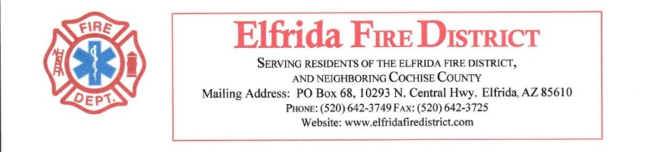

FIREFIGHTER JOB DESCRIPTION
Classification Responsibilities: Firefighters perform public safety work involving the protection of life and property by fighting fires, responding to emergency incidents, using Emergency Medical Services (EMS) skills, engaging in fire code enforcement, public education, as well as station and equipment maintenance activities. The firefighter is responsible for performing related duties as required.
- Distinguishing Features:
  - Firefighters are required to work 24hour shifts, and may be assigned to work a day assignment (40hour work week) while assisting on special projects.
  - Work at the fire station and on scenes of fires is inspected in progress and upon completion by a Fire Captain, and is normally performed under close supervision in accordance with well-defined procedures.
  - A Firefighter may act as a Fire Engineer or Fire Captain on a relief or training basis.
  - This class is FLSA nonexempt.
- QUALIFICATIONS Minimum Qualification(s) Required:
  - Must be 21years of age by hire date.
  - Must have high school diploma or equivalent.
  - Must have current State of Arizona Emergency Medical Technician (EMT) or Paramedic certification.
  - Must pass annual physical agility test
  - Must pass health screening
  - Must pass pre-employment and annual drug screening
  - Must sign a Loyalty Oath.
  - Must meet insurability requirements of the Department’s insurance carrier.
  - Must have satisfactory results on background screening, including fingerprint clearance card
- Paramedic Requirements:
  - Current Arizona Paramedic Certification
  - Current ACLS
  - Current PALS
  - Current Healthcare Provider CPR from AHA or Red Cross
  - Must possess a valid Arizona Driver’s License by hire date.
  - Must meet the qualifications to wear a tight-fitting respirator by passing a medical evaluation test in accordance with CFR 1910.134 by hire date and must maintain certification.
- EMT Basic Requirements:
  - Current Arizona EMT Basic Certification
  - Current Health Care Provider CPR from AHA or Red Cross Special Requirement(s):
  - Must possess a valid Arizona Driver’s License by hire date.
  - Must meet the qualifications to wear a tight-fitting respirator by passing a medical evaluation test in accordance with CFR 1910.134 by hire date and must maintain certification.
Substance Abuse Testing: Due to the safety and/or security sensitive nature of this job, individuals shall be subject to pre-employment or pre-placement alcohol, drug and/or controlled substance testing as outlined in district policies and procedures.
- Preferred/Desirable Qualification(s):
  - Coursework toward an Associate’s Degree in Fire Science or Fire Science Technology from a regionally accredited college or university is preferred.
  - Bilingual in Spanish is desirable.
- ESSENTIAL FUNCTIONS Communication:
  - Communicates with the general public and other employees in performing community service and public education activities, conducting business inspections, presenting public safety training classes, participating in school programs, answering questions, delivering emergency care, and ensuring patient needs.
  - Produces written documents to document technical and legal matters.
  - Completes all patient care reports prior to completion of shift.
- Environment:
  - Works in extreme heat
  - Works in extreme cold
  - Works on heights above ground level
  - Works on ladders
  - Works in loud environments
  - Works in all lighting variations from well light to dark
  - Sleeps in dorm rooms with other team members
  - Works 24 hour shifts
  - Works in a multitude of hazardous atmospheres and environments including but not limited to: Violent, Oxygen deficient, Hazardous Chemical spills, biohazards, and any other environment that may or may not be encountered on an emergency call

